Tuesday 24th May 2022

Chemistry Paper 1 Revision

Types of Bonds

Ionic Bonding:

When a metal and non-metal react, the metal **loses** electrons to become stable, and the non-metal **gains** those electrons. The electrons are “transferred” from the metal to the non-metal.

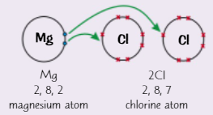

Covalent Bonding

Two non-metal atoms “share” electrons in a covalent bond in order to become stable. Each bond provides **1** atom to share.

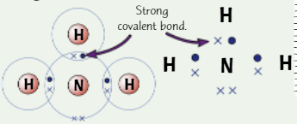

Metallic Bonding

The giant structure of positive metal ions is held in place by the negatively charged delocalised electrons. These electrons give metals their properties.

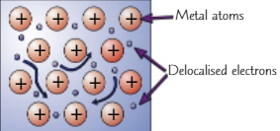

Properties of Bonded Structures

Ionic Compound:

* Made of positive and negative ions
* Electrostatic attraction between opposite charged ions creates strong bonds **in all directions**.
* Normally formed when metals react with non-metals
* Examples include table salt (NaCl)

Giant Ionic Structures:

* High melting and boiling points due to strong bonds
* Can conduct electricity when molten/liquid due to delocalised (free) electrons.

Giant Covalent Structures:

* Very High melting and boiling points
* Insoluble in water
* Do not conduct electricity (except graphite)

Giant Metallic Structures

* Conducts heat and electricity due to delocalised electrons
* Malleable (can be shaped) due to the separate layers of metal ions that can slide past each other
* Ductile (can be drawn into a wire) due to separate ion layers
* High melting point due to strong electrostatic bonds

Group 1 Metals (Alkalis)

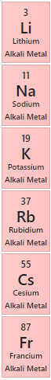These elements all have **one electron** in their outermost shell, making them very reactive, and giving them similar properties. The trends for the group 1 element are:

* Increasing reactivity moving down the group
* Lower melting and boiling points
* Higher relative atomic mass

Reactions:

* All alkali metals react form ionic compounds with non-metals (for example NaCl – table salt) because it is easy for them to lose their outer electron.
* Reacts vigorously with water, producing hydrogen gas:
* Reacts with chlorine to produce a salt when heated:
* Reacts with oxygen to form a metal oxide (making them become dull)

Group 7 Elements (Halogens)

The halogens are a group of **toxic non-metals** that have **coloured vapours.** They have many of the common properties of non-metals:

* Low melting and boiling point that increases moving down the group.
* Poor conductor of heat and electricity
* Diatomic Molecules – Exists as two covalently bonded atoms (for example Cl2, F2)

Reactions:

* Reacts with non-metals to gain an electron by sharing a pair of electrons, for example 2HCl.
* Reactivity decreases moving down the group
* Reacts with metals to for negative ions (F **-**, Cl **-)**
* A more reactive halogen will **displace** a less reactive halogen from solutions or its salts.

Moles

Relative Atomic Mass (Ar) – The relative mass (weight) of an atom, compared to Carbon-12. It is used because the actual mass of an atom is very small.

Relative Formula Mass (Mr) – The relative mass of a compound (for example CO2 is 12 (Carbon) + 16 (Oxygen) + 16(Oxygen) = 46)

Mole – The relative atomic/formula mass of any substance in grams. A mole always contains the same number of atoms/molecules/ions: . This value is called the **Avogadro Constant.**

Concentrations of Solutions

Concentration is calculated using this equation:

Note – 1 Decimetre (dm3) is equal to 1000cm3

Reactions of Acids

The salt formed in a reaction with acids depends on the acid involved. The reactant and acid react, which produces a salt:

* Hydrochloric Acid (HCl) – Chloride, for example Sodium Chloride (NaCl)
* Sulfuric Acid (H2SO4) – Sulphate, for example Calcium Sulphate (CaSo­4)
* Nitric Acid (HNO3) – Nitrate, for example Copper Nitrate (CuNO3)

Acids and Metals

* Metals react with an acid to produce a salt:
* Reactions between metals and acids only occur **when the metal is more reactive** than the hydrogen in the acid.
* This is a **redox** reaction – The metal is **oxidised,** and the hydrogen ions in the acid are **reduced.**

Acids and Alkalis

* When an acid reacts with an alkali, a neutralisation reaction takes place:
* The H+ ions in the acid react with the OH- ions from the alkali to form water:

Acids and Carbonates

* Metal carbonates react with acids to produce a salt, water, and carbon dioxide:

Endothermic and Exothermic Reactions

When a reaction takes place, energy is either given off into the environment (exothermic) or taken from the environment (endothermic). The overall amount of energy never changes – Conservation of Energy **(“Energy is never created or destroyed”).**

Exothermic:

* If the energy of the **products is lower** than the energy of the reactants, the reaction is **exothermic.**
* In **exothermic** reactions, energy is transferred to the surroundings.
* Examples include combustion, neutralisation, and many oxidation reactions.

Endothermic:

* If the energy of the **reactants is lower** than the energy of the products, the reaction is **endothermic.**
* In **endothermic** reactions, energy is taken in from the surroundings.
* Endothermic reactions are less common than endothermic, but an example includes thermal decomposition ()